DISTRIBUTED TRACING

What is Distributed Tracing?
Distributed tracing is a method of tracking application requests as they flow from frontend devices to backend services and databases. Developers can use distributed tracing to troubleshoot requests that exhibit high latency or errors. In this article, we’ll cover how distributed tracing works, why it’s helpful, and tools to help you get started.

How Distributed Tracing Works
Applications may be built as monoliths or microservices. A monolithic application is developed as a single functional unit. In microservice architecture, an application is broken down into modular services, each of which handles a core function of the application and is often managed by a dedicated team.
End-to-end distributed tracing platforms begin collecting data the moment that a request is initiated, such as when a user submits a form on a website. This triggers the creation of a unique trace ID and an initial span—called the parent span—in the tracing platform. A trace represents the entire execution path of the request, and each span in the trace represents a single unit of work during that journey, such as an API call or database query. Whenever the request enters a service, a top-level child span is created. If the request made multiple commands or queries within the same service, the top-level child span may act as a parent to additional child spans nested beneath it. The distributed tracing platform encodes each child span with the original trace ID and a unique span ID, duration and error data, and relevant metadata, such as customer ID or location

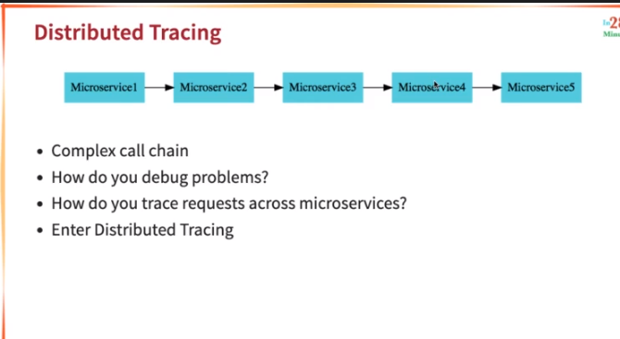
HOW DOES A DISTRIBUTED TRACING WORKS
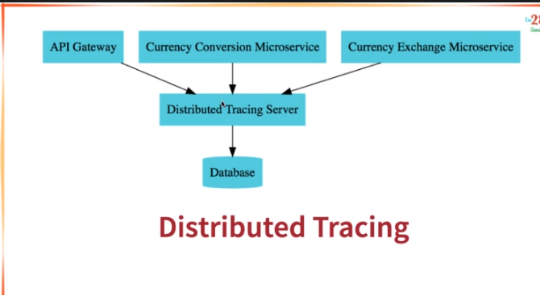
in distributed tracing what happens is that we will be having a distributed tracing server to which our all the microservices will be connected and will keep sending the data and then the distributed tracing server will store it in a databse and then we will be able to trace our request.

Now lets have alive demo:
We will run the zipkin using a docker image.
We do not need to install any zipkin server onto our machine this all will be present in the docker image
Zipkin runs on port 9411

Docker run -p 9411:9411 openzipkin/zipkin:2.23
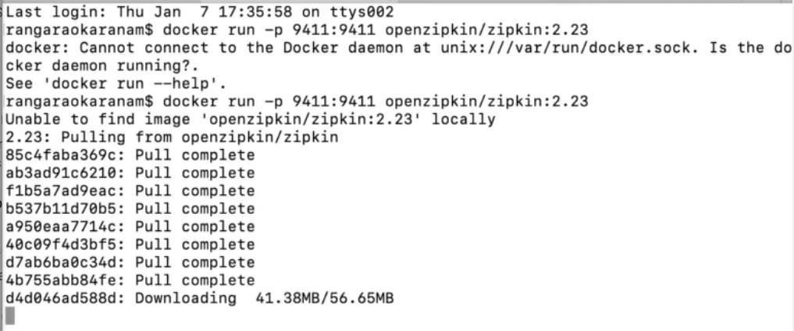
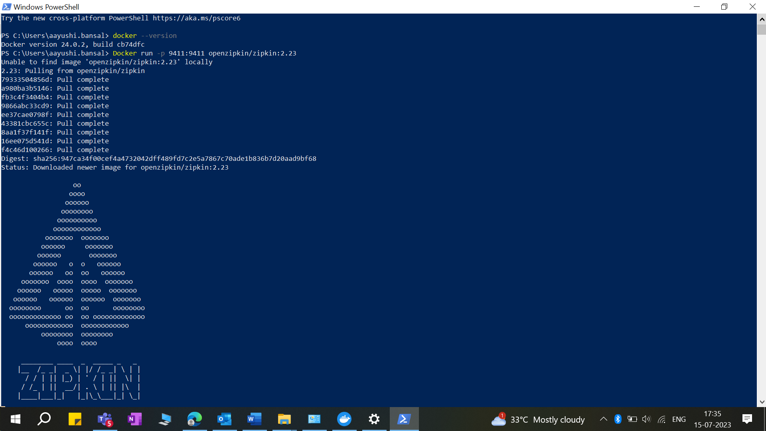

What the above command will do is that it will download the zipkin image from the docker hub,then store it in local and then run it.

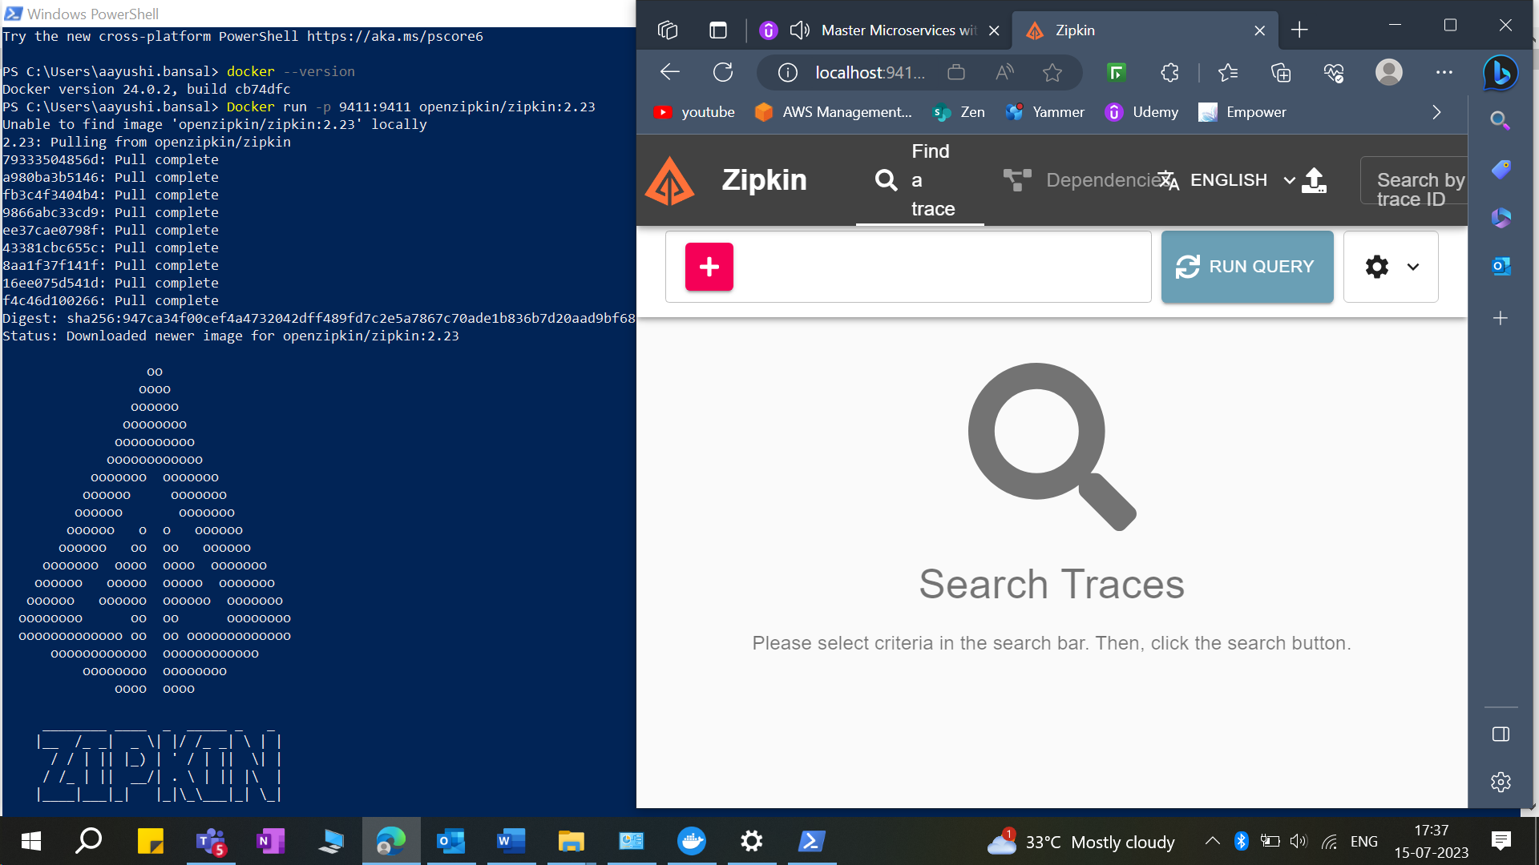
Zipkin is launched on our machine

Create Zipkin Server, visit https://zipkin.io/
Go to quickstart and download latest jar and run it, java -jar jarname.jar
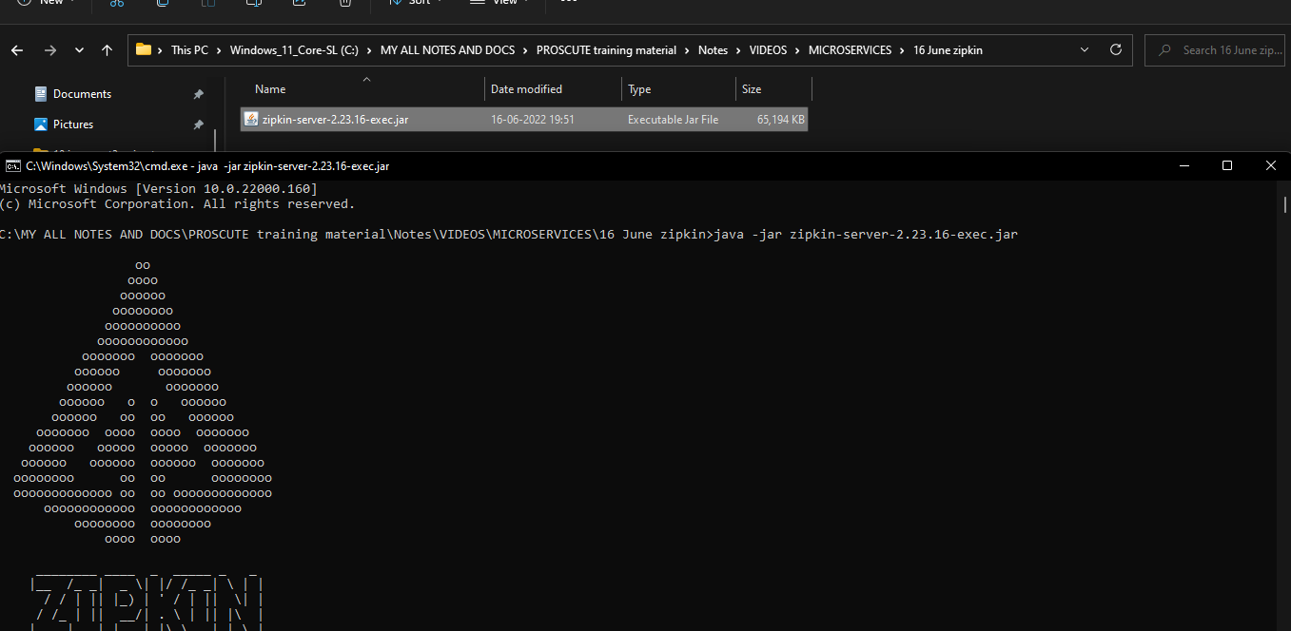
Open the zipkin server url on browser
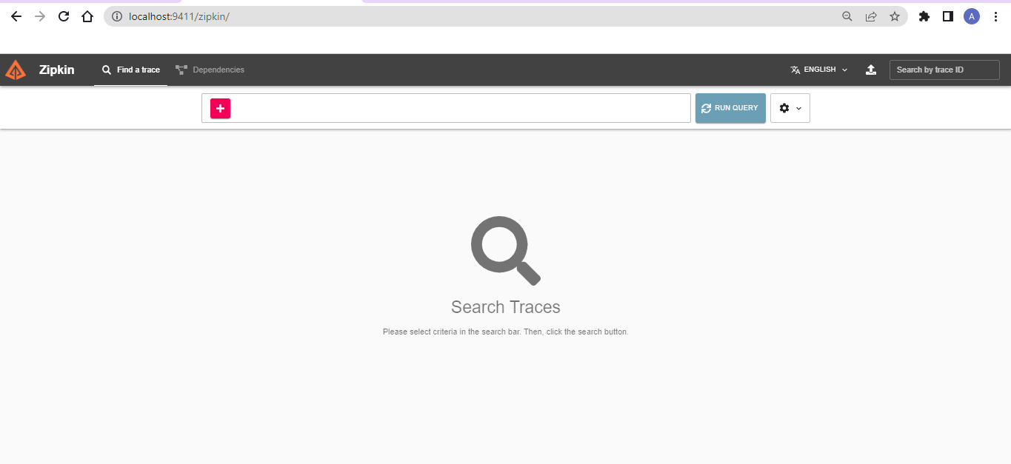

Now we will move on to another topic
Observability and telemetry

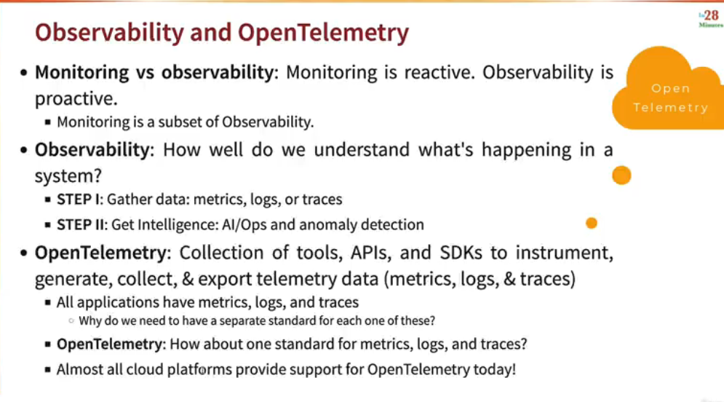

CASE STUDY
Why we use zipkin tracing
\ we use zipkin tracing in the case suppose our microservice is taking too too long to respond then we need to check where is the microservice taking time.we need to analyze as in in which microservice it is taking a longer time.
We can do all the above using the zipkin
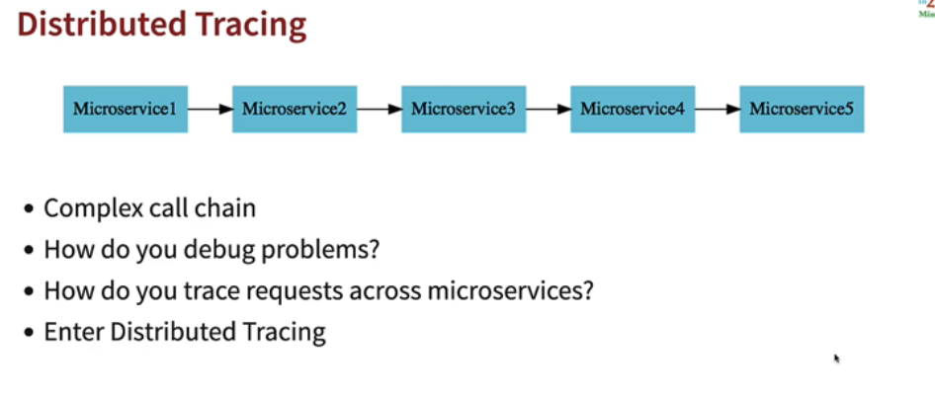

One of the most useful tool is zipkin which is used for zipkin tracing.
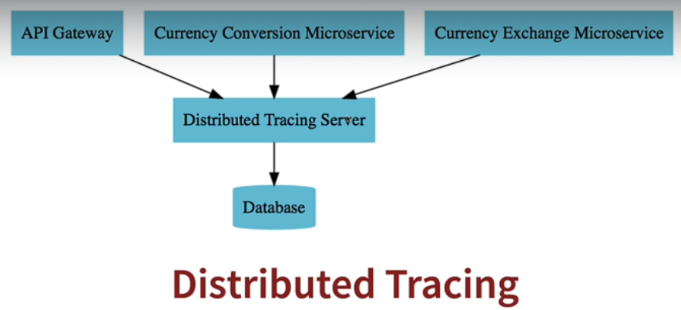

All our microservices will be sending the data to the distributed tracing server which will be having its database where it will store all the data and then tracing server will show us the requested information on the ui.

SPRINGBOOT 3 VERSIO FOR TRACING
If we are using springboot 2 then we can have the below dependencies in our project:
<dependency>
<groupId>org.springframework.cloud</groupId>
<artifactId>spring-cloud-starter-sleuth</artifactId>
</dependency>
<dependency>
<groupId>org.springframework.cloud</groupId>
<artifactId>spring-cloud-sleuth-brave</artifactId>
</dependency>
<dependency>
<groupId>org.springframework.cloud</groupId>
<artifactId>spring-cloud-sleuth-zipkin</artifactId>
</dependency>

In order to work in springboot 2we need to have the above dependencies added to our pom.xml.

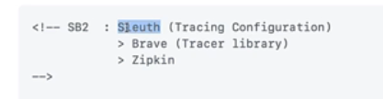
Earlier springboot 2 used sleuth,brave
But now in springboot 3
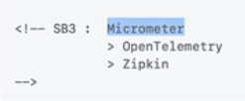

In springboot we have moved to open frameworks

But now in spring3 we need to have below dependencies in our project:
<dependency>
<groupId>io.micrometer</groupId>
<artifactId>micrometer-observation</artifactId>
</dependency>

<!-- OPTION 1: Open Telemetry as Bridge (RECOMMENDED) -->
<!-- Open Telemetry
- Simplified Observability (metrics, logs, and traces) -->

<dependency>
<groupId>io.micrometer</groupId>
<artifactId>micrometer-tracing-bridge-otel</artifactId>
</dependency>

<dependency>
<groupId>io.opentelemetry</groupId>
<artifactId>opentelemetry-exporter-zipkin</artifactId>
</dependency>

2. After adding the dependency we need to specify the sampling in application.properties

management.tracing.sampling.probability=1.0
logging.pattern.level=%5p [${spring.application.name:},%X{traceId:-},%X{spanId:-}]

if we want to trace every request then we give sampling as 1.0
else we can give 0.4

EFFECTIVE WORKING TECHNIQUES

1.Adding the below dependencies to every project:
<dependency>
<groupId>org.springframework.boot</groupId>
<artifactId>spring-boot-starter-actuator</artifactId>
</dependency>
<dependency>
<groupId>io.micrometer</groupId>
<artifactId>micrometer-tracing-bridge-brave</artifactId>
</dependency>
<dependency>
<groupId>io.zipkin.reporter2</groupId>
<artifactId>zipkin-reporter-brave</artifactId>
</dependency>
<dependency>

To application.properties of api gateway,service registry and all other applications add
management.tracing.sampling.probability=1.0

now run your application

now go to zipkin server and find the logs.

3.now in the project from which a call to other service is going and is using feighn
<dependency>
<groupId>io.github.openfeign</groupId>
<artifactId>feign-micrometer</artifactId>
</dependency>

The above dependency enables tracing of rest api calls made using feign

